Rolando Ortega Arocho SDEV-435-81

The Link Social Media

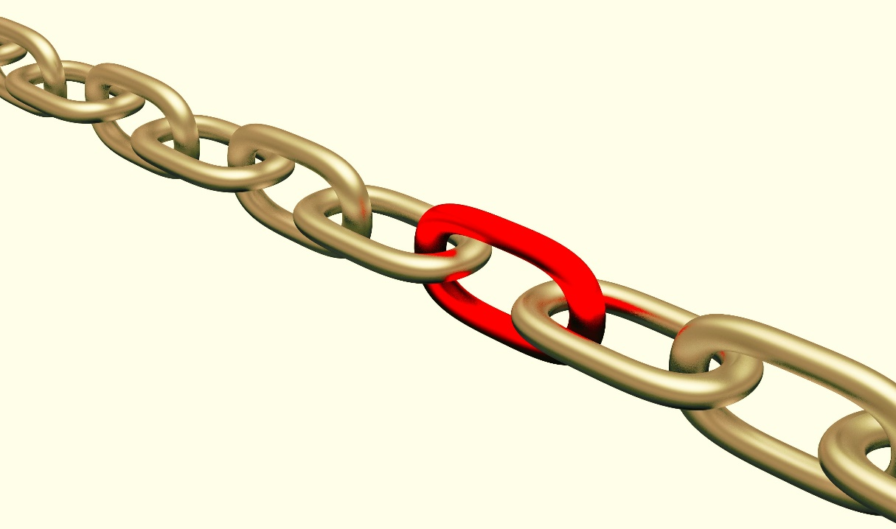

# Executive Summary

For this assignment I choose to ceated a a social media web application. The internet changed the way people interact with each other as well as work culture, and those changes first arose on social media sites. That is why social networks for apps are so important.

Social media helps people establish better relationships with their family and friends, and now the networking sites also show their significance for apps.

That is why people spend a lot of their time online browsing social sites, and usage has only gone up with increase in the use of smartphones and tablets in

Mobile devices are gaining more and more space amongst people when compared to other ways of internet access. It is because prices and plans have become increasingly affordable and accessible.

Mobile accessibility in turn lures people to always stay online thus encouraging more time spent on social media. My objectives are going to be:

* Create a social network where the user can meet people.
* A webpage where the user can be in touch with family and friends.
* A page where people can join groups to comment, share information and opinion.
* The option to share pictures and videos.
* Information about places with reviews.

As well my Target audience are:

* Males and Females 20+
* Live in Texas U.S
* Meet cultures and diversities
* Using different types of operation systems
* Easy to use for all level of computer knowledge

The style or site type is:

* Billboard (A site providing important information for especial interest groups and nonprofit organizations and providing multiple levels of information with page templates, extracting information from data-bases.

The budget is in process and it will be update when its finalized and the web application is fully completed.

# Scenario | Program Usage Description

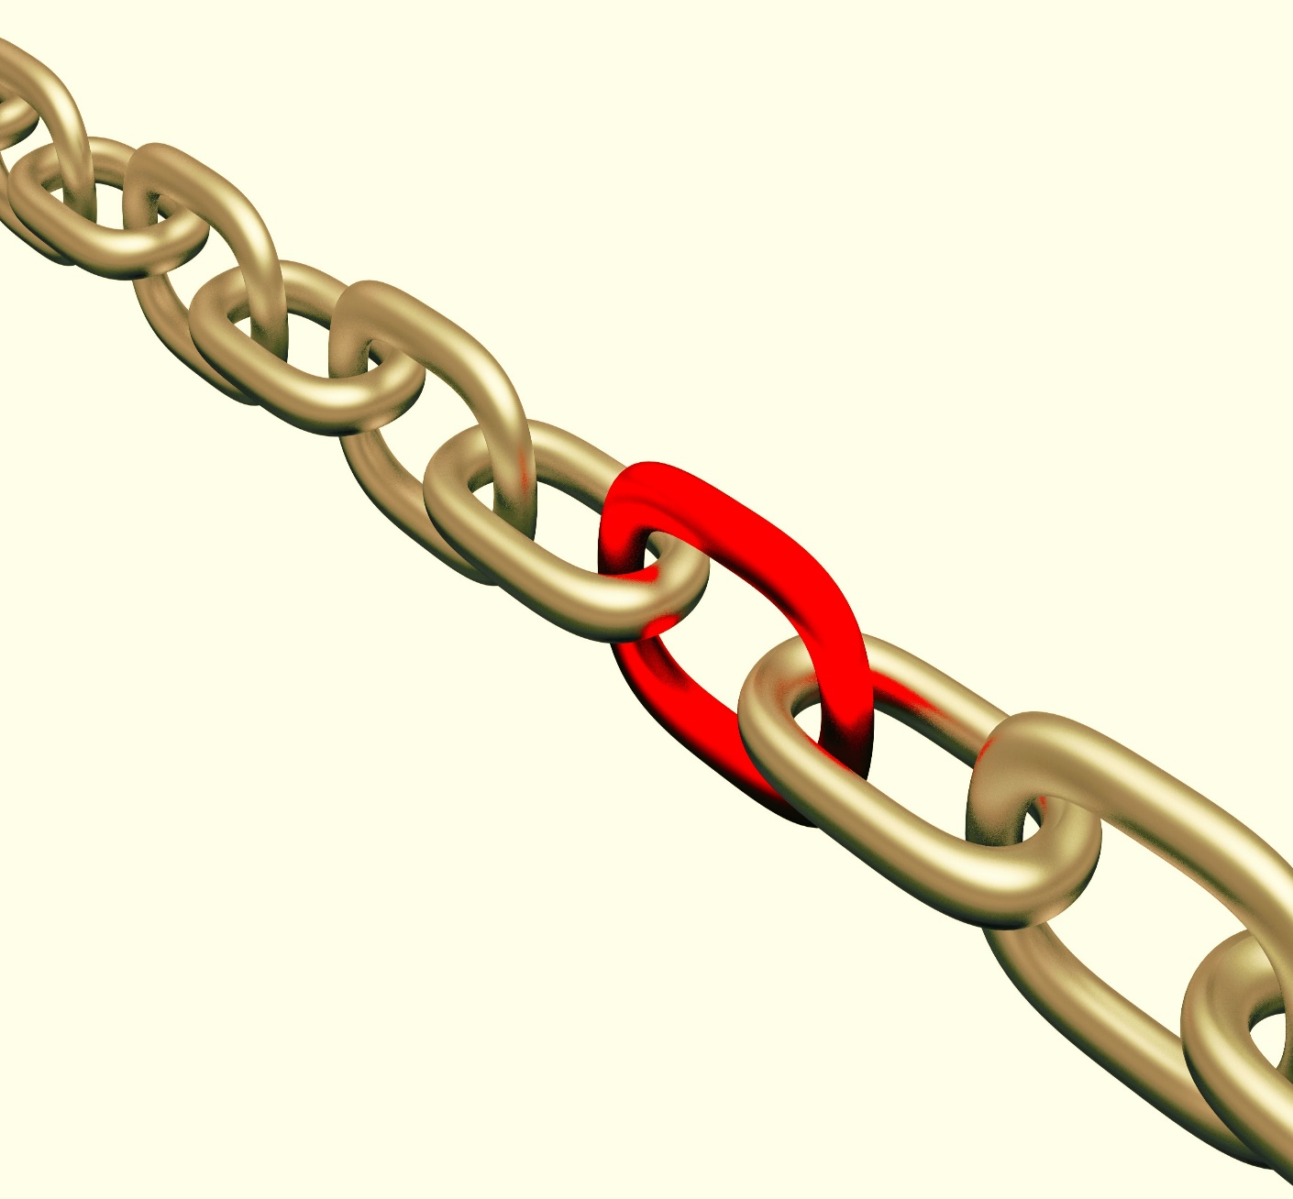

1. The user visits **Error! Hyperlink reference not valid.** *to see places to go.*
2. The system displays the home page in the browser with the logo.

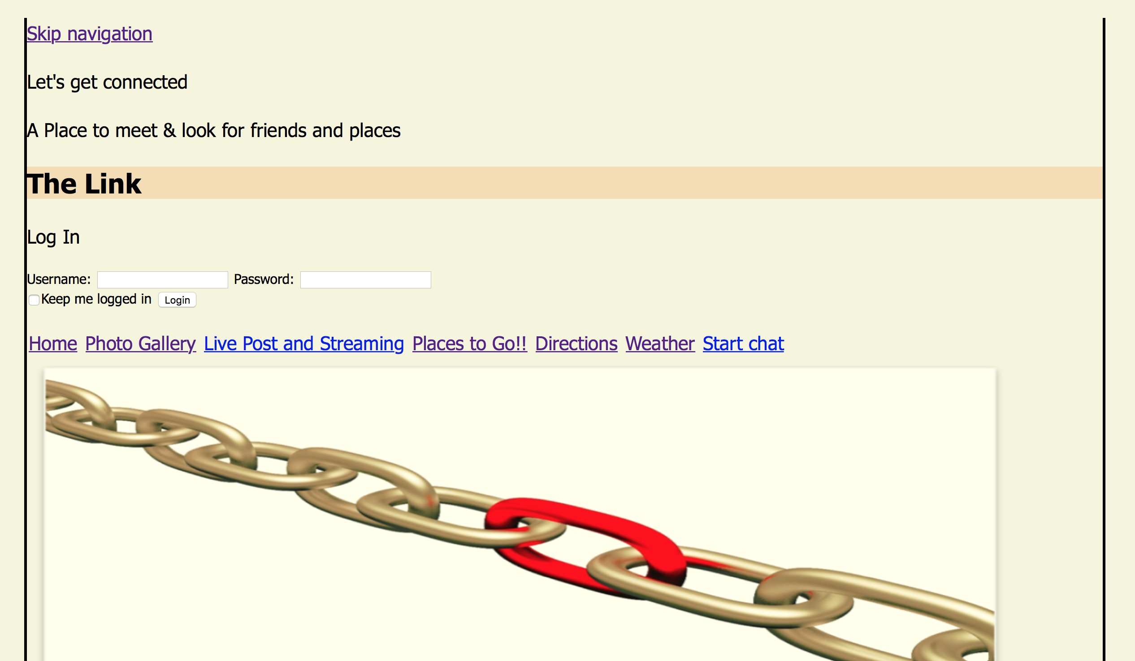

1. The user clicks the "login" link and it will show username and password.
2. The system presents the login page.

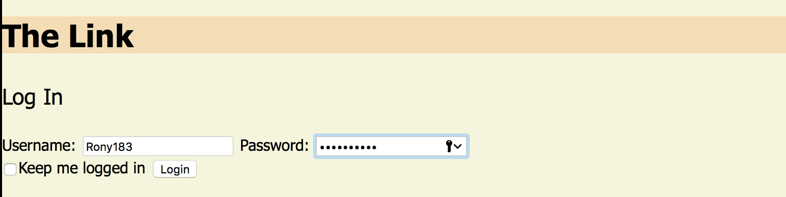

1. The user enters their username and password correct and hits the enter key.



1. The system presents the user with a main page with the logos and an easy browser search.



1. Including in the main page it will have couple of tables like: Photo Gallery, Live post and streaming, Video Chat, Places to Go with Reviews, Maps and directions using GPS.
2. The GPS will consist of an interface to utilize either way using IOS system and android system.

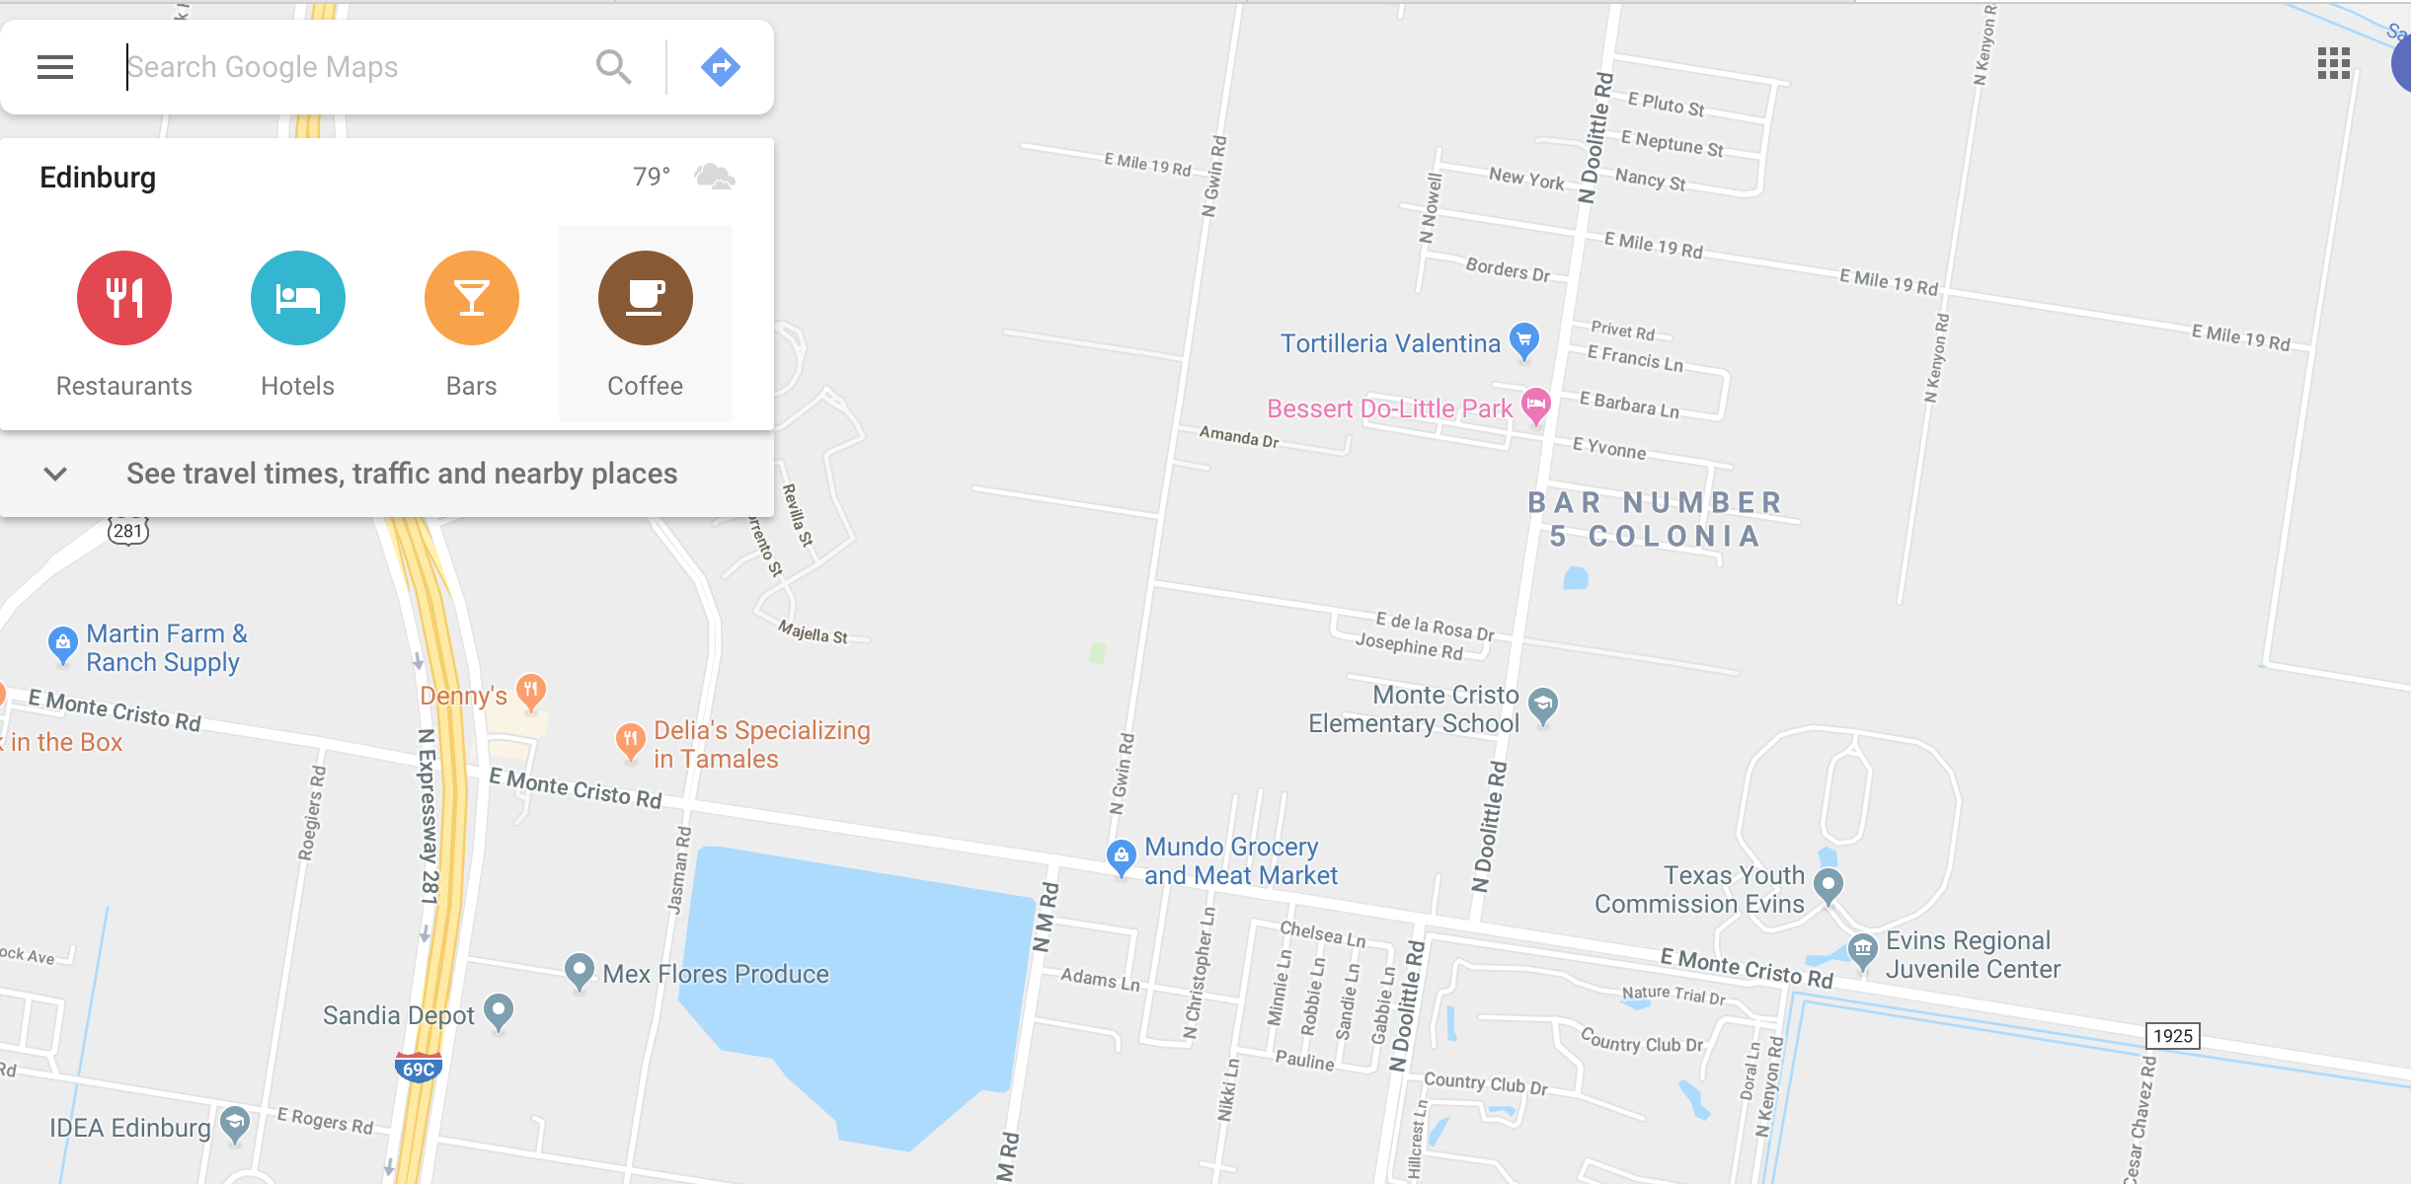

1. The person clicks under Places to Go with reviews to decide where to go.

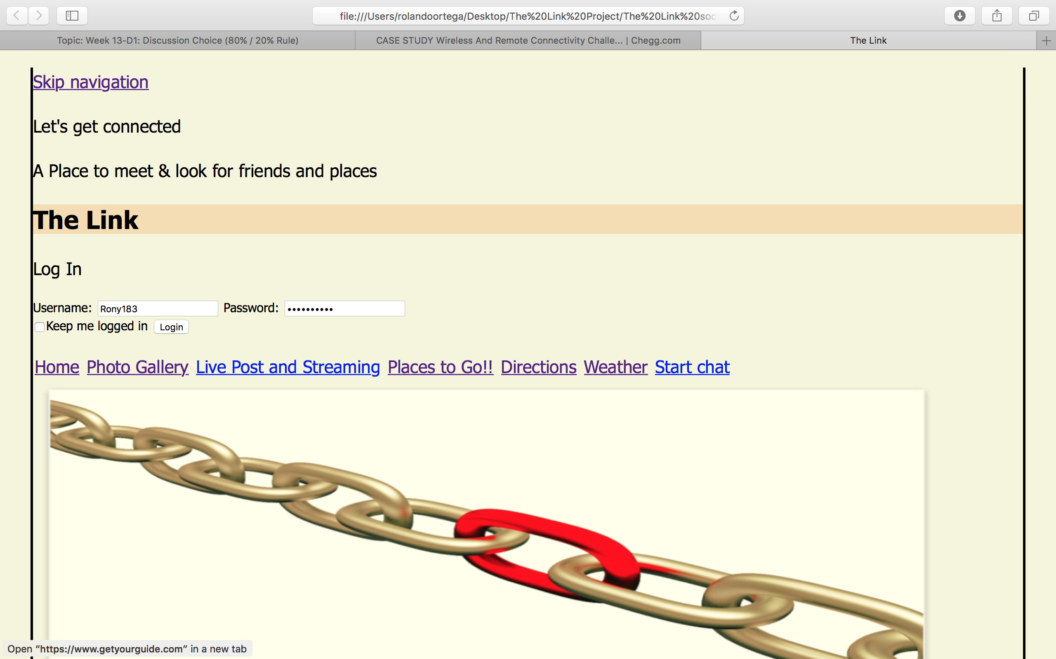

1. The person began to utilizes a small window with a chat to talk with his/her friend through Skype. A notification will pop please click allow.

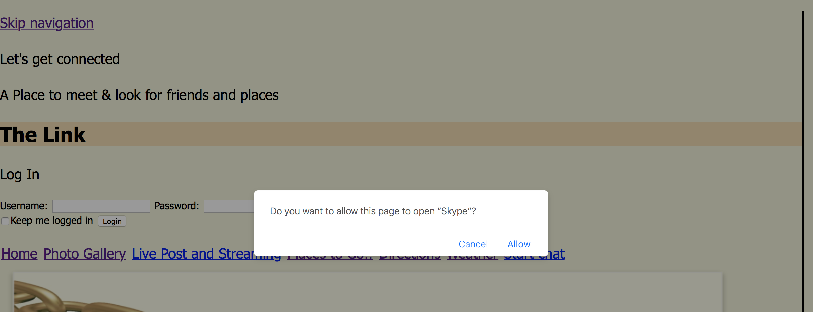

1. They are chatting and deciding where to go to spend some time.

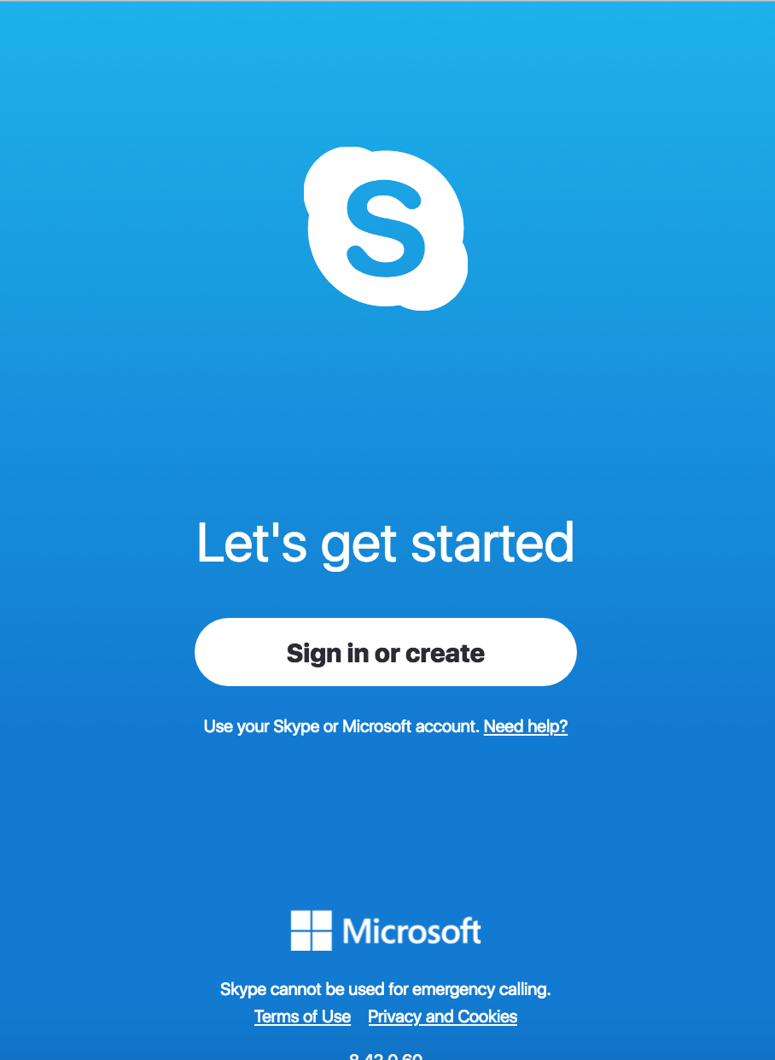

1. The person using the video chat with his friends decided when to go to the place. They decided to go the same night.
2. They click a small window next to where to go section and activated a search page it should pop.

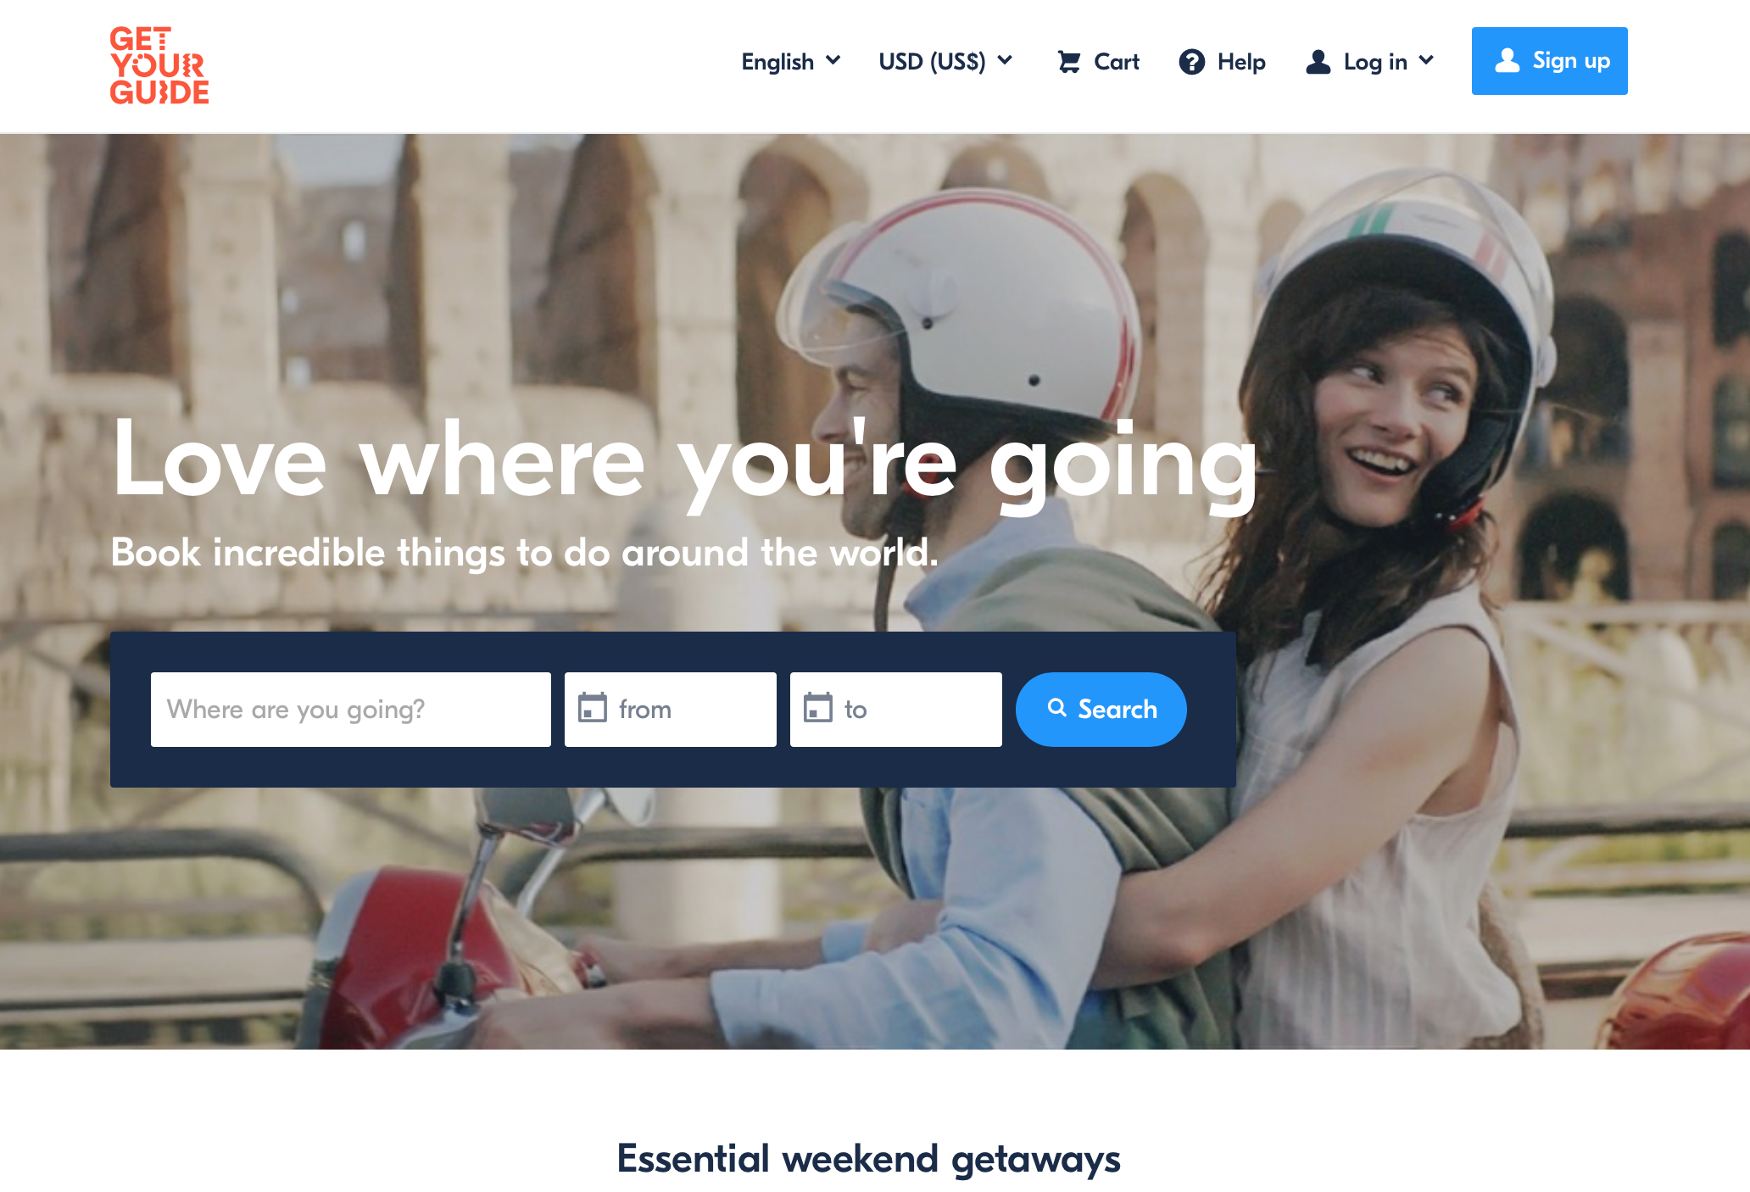

1. They are using the GPS to be able to know the exact location.



1. Also, they are looking for the weather section for that night, to make the decision if they want to go outdoors or a local.
2. The weather section shows a good weather, 80 degrees Fahrenheit with just a 10% of humidity.

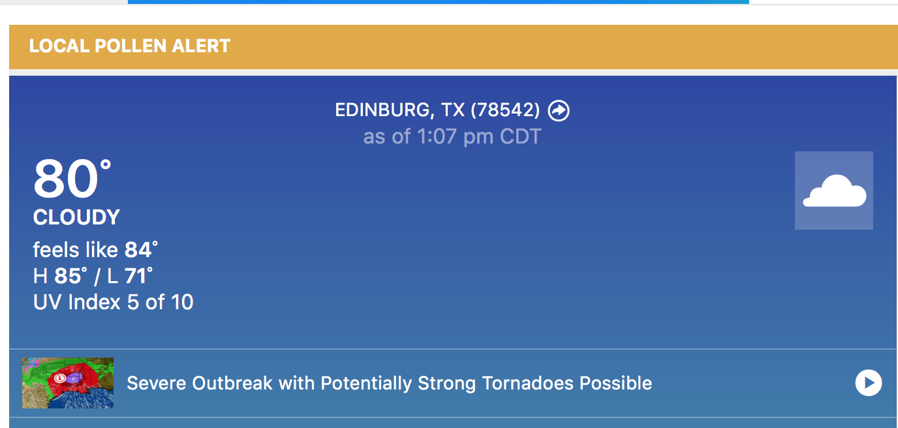

1. They decided to go to a food truck park, in where you can find another activity like a mini golf court, arcades, basketball court and amusement rides.

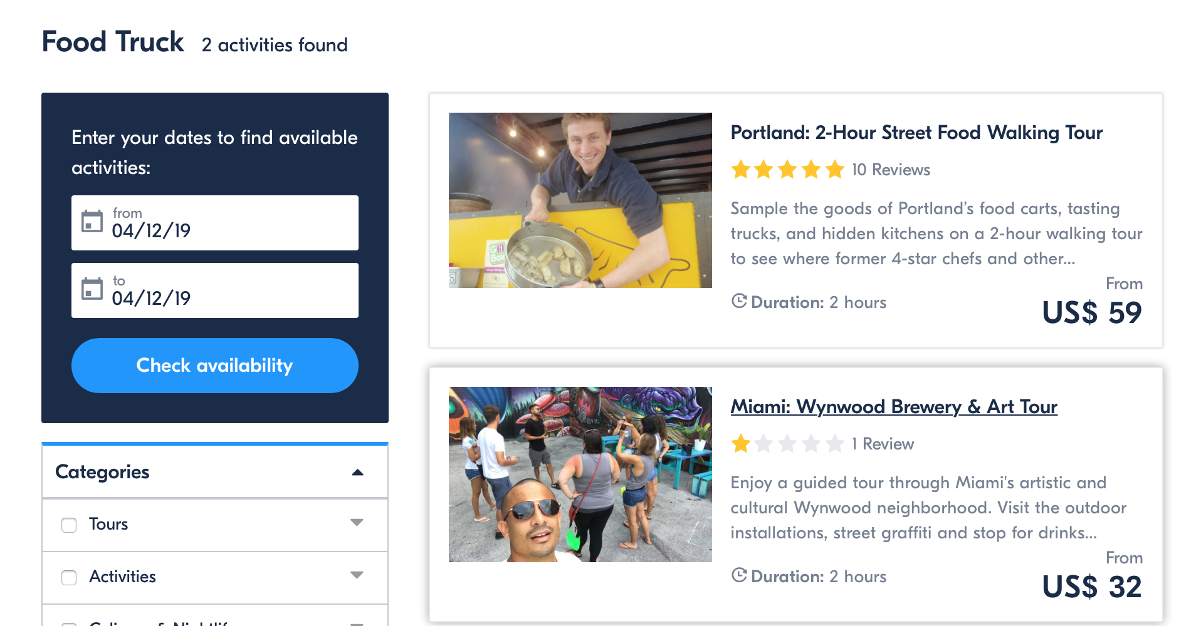

# Reports

For this assignment I will select a social media web application. The internet changed the way people interact with each other as well as work culture, and those changes first arose on social media sites. That is why social networks for apps are so important.

Social media helps people establish better relationships with their family and friends, and now the networking sites also show their significance for apps.

That is why people spend a lot of their time online browsing social sites, and usage has only gone up with increase in the use of smartphones and tablets in

Mobile devices are gaining more and more space amongst people when compared to other ways of internet access. It is because prices and plans have become increasingly affordable and accessible.

Mobile accessibility in turn lures people to always stay online thus encouraging more time spent on social media. My objectives are going to be:

* Create a social network where the user can meet people.
* A webpage where the user can be in touch with family and friends.
* A page where people can join groups to comment, share information and opinion.
* The option to share pictures and videos.
* Information about places with reviews.

As well my Target audience are:

* Males and Females 20+
* Live in Texas U.S
* Meet cultures and diversities
* Using different types of operation systems
* Easy to use for all level of computer knowledge

The style or site type is:

* Billboard (A site providing important information for especial interest groups and nonprofit organizations and providing multiple levels of information with page templates, extracting information from data-bases.

The user will be able to update their posting, what our friends are doing, we also want to let them know what we are up to, how we feel today, and what we think about something. Options similar to existent social medias like Facebook and twitter.

The implementation of real text in text-based content was done. Example: in frequently questions and contact I added contact real information like address, phones and questions about my web story board. Subject can do this by clicking the logo or searching in the we browser at the top of the first page.

The subject will be able or enable a GPS locator to get access and routes to different destinations.

Access to this social web will be granted in the first page, under created an account if the person has already an account and does not remember his password or user name can request his or her user account by clicking forgot password or username.

Access to live video streaming will be granted automatic after user goes to the second page. From photo gallery subject can select any picture to be used as a profile picture.

Weather will be in constant change due to variation of the days.

Monitoring of the link will be done periodically because links become broken over time. With changes within the site and if you referenced someone in one of your articles or somewhere else within the site links could have changed or are broken.

Possibility to use Site up because is a small program that runs on your computer in the background checking your site on a regular basis. It will notify you when the site is down with a popup. Obviously though, your computer has to be on for it work.

# System Architecture

Local Database

Admin

External Websites (weather Channel, Google maps etc.)

Social Media

## 

Weather

Time

GPS cords

SsSS

Logging Process

Home Page

Live Post and streaming

General Mining Results

Figure showing an interaction between the social media web and external links. The system it will give the more accurate analysis between both. With this system user can use both websites in the same location. One link it will take the user to another external page showing the weather, address, location and the GPS cords.

## Source Code Structure

For the directory I saved all my code in a single file called The Link Project

|  |  |
| --- | --- |
| **Code Directory** | |
| **Directory** | **Usage** |
| The Link Project/Desktop  The Link Social.html | Main Page utilizes for logging and link external web sites.  **CODE**  <!DOCTYPE html>  <html lang="en">  <head>  <title>The Link</title>  <!--  The Link social media main page  Filename: The Link.html  Author: Rolando Ortega  Date: 2/13/2019  -->    <meta charset="utf-8">  <meta name="viewport" content="width=device-width">  <script src="modernizr.custom.62074.js"></script>  <link href="https://fonts.googleapis.com/css?family=Bitter" rel="stylesheet"type='text/css'>  <link href="style.css" rel="stylesheet" type="text/css" />  <link rel="shortcut icon" href="images/favicon.ico">  <link rel="apple-touch-icon" href="images/apple-touch-icon.png">  <link rel="icon" sizes="192*192" href="images/android.png">  </head>  <body>  <div class="container">  <p class="skipnavigation"><a href="#contentstart">Skip navigation</a></p>  <p> Let's get connected </p>  <header>  </nav>  <article>  <p id="contentstart">  <div>  <h2></h2>  <p class="accent">A Place to meet <span class="accent">&amp; look for friends and places</p>  </div>  <h1>The Link</h1>  <form>  <p>Log In</a></p>  </div>  <div id="container">  <label for="username">Username:</label>  <input type="text" id="username" name="username">  <label for="password">Password:</label>  <input type="password" id="password" name="password">  <div id="lower">  <input type="checkbox"><label for="checkbox">Keep me logged in</label>  <input type="submit" value="Login">  </div><!--/ lower-->  </form>  <nav class="sitenavigation">  <p><a href="Home.html" target="_blank">Home</a></p>  <p><a href="Photos.html"target="_blank">Photo Gallery</a></p>  <p><a href="Live Post and Streaming.html"target="_blank">Live Post and Streaming</a></p>  <p><a href="https://www.getyourguide.com" target="_blank">Places to Go!!</a></p>  <p><a href="https://www.google.com/maps/@26.3361661,-98.1279967,15z" target="_blank">Directions</a></p>  <p><a href="https://weather.com" target="_blank">Weather</a></p>  <p><a href="skype:-skype-name-?chat" target="_blank">Start chat</a></p>  <img src="images/The Link.png" width="1100" height="400" alt="The Link">  </header>  </div>    <footer>  <p id="contact"><span class="accent">Rolando</span> &#8226; Ortega (956)800-8917</p>  </footer>  </html> |
| The Link Project/Desktop  Style.css | Stylish all the html pages, giving form, color border, sizes.  **CODE**  /* body*/  body {  max-width: 1200px;  margin: 0 auto;  border-left: 3px solid black;  border-right: 3px solid black;  border-bottom: 3px solid black;  background-color: beige;  text-align: left;  font-family: Tahoma, Arial, Helvetica, sans-serif;  box-shadow: 0 29px 6px -6px #777;  }  nav.sitenavigation p  {  display: inline-block;  margin: 0.5em;  float: center;  }  nav.sistenavigation {  /* width: 19%; */  /* padding: 3%; */  /* float: left; */  color: #3418f;  text-align: center;  float: center;  }    nav.sitenavigation p {  display: inline-block;  margin: 0.10em;  float: center;  }  nav.sitenavigation a: link{  text-decoration: none;  color: #34180f;  }  nav.sitenavigation a: visited {  color: #744f42;  }  nav.sitenavigation a: hover, nav.sitenavigation a:focus {  color: ivory;  }  /* Basics */  p {  font-size: 1.4em;  line-height: 1.6em;  }  a: link {  color: black;  }  a: visited {  color: #888;  }  a: active {  position: relative;  top: 1px;  left: 1px;  }  }  #contact {  text-align:right;  }  .accent {  color: black;  }  h1, #contact {  background-color: wheat;  color:black;  position: right;  font-size: 2em;  }  /* reset styles*/  html {  font-size: 15px;  }  a, article, body, div, footer, header, h1, h2, p {  p {  font-size: 1.2em;  line-height: 1.4em;  padding: 0;  margin: 0;  }  img {  max-width: 400%;  height: auto;  width: 100;  position: center;  margin: relative;  }  /* body and page container */  .container{  max-width: 800px;  margin: 0 auto;  background-color: blue;  position: relative;  top: 6.2em;  }  /*heading */  h1,h2 {  padding: 0.8em;  text-align: right;  font-family:Bitter, "Times New Roman", Times, serif;  }  header {  width: 100%;  max-width: 640px;  position: fixed;  background-color: darkgreen;  /*z-index: -1;*/  }  /* skip navigation Link*/  p.skipnavigation a {  position: absolute;  left: -10000px  }  p.skipnavigation a:focus{  color: #34180f;  background-color: ivory;  top: 0.2em  left 0.4em  z_index 2;  }  h1 {  color: ivory  background-color: rgb(184,148,77);  font-size: 2em  padding: 0.8em;  color: black;  text-align: center;  text-shadow: -10px -5px 6px rgb(52,24,15);  }  h2 {  font-size: 3em  padding: 0.4em 0.6em;  vertical-align: : -50px;  }  p.logo {  padding: 0.2em;  border: 2px solid beige;  color: black;  position: all;  top: 2em;  left: 2em;  }  /* main content */  article {  /* width: 69%; */  margin: 0 auto;  padding: 0 3% 1em;  background-color: #7eccec;  background: url("images/ocean.png");  /* float: right; */  }  article{  width: 70%;  float: right;  }  article p{  padding: 0 1em 1em;  }  article p.imagemap{  text-align: center;  }  article p.imagemap img{  border: 1px solid black;  max-width: none;  }    article p: first-line{  font-weight: bold;  }  article p: first-letter {  font-size: 3em;  float: left;  line-height: 0.9em;  }  .tittle{  font-style: italic;  }  /* sidebar */  aside {  width: 30%;  padding: 1em 0;  background-color: goldenrod;  }  aside p {  border-bottom: 1px solid black;  border-top: 1px solid black;  padding: 0.4em 0;  margin: 0 0.6em;  }  /*footer section*/  footer{  padding: 0.6em  color:white;  background-color: rgb(24,24,24);  text-align: center;  /* clear:both; */  }  footer p {  margin: 0.4em;  }  .accent{  font-weight: bold;  }  footer p.accent{  color: goldenrod;  } |
| The Link Project/Desktop  Image | Description of this directory’s contents and usage. |
| The Link Project/Desktop  Live Post and streamin.html | Given the option to post comments and videos  **CODE**  <!DOCTYPE html>  <html lang="en">  <head>  <title>Live Post and Streaming</title>  <p> Let's get connected</p>  <p> Live Post and Streaming</p>  <nav class="pagenavigation">  <!--  The Link social media main page  Filename: The Link.html  Author: Rolando Ortega  Date: 2/13/2019  -->  <meta charset="utf-8">  <meta name="viewport" content="width=device-width">  <script src="modernizr.custom.62074.js"></script>  <link href="https://fonts.googleapis.com/css?family=Bitter" rel="stylesheet"type='text/css'>  <link href="style.css" rel="stylesheet" type="text/css" />  </head>  <body>  <div class="container">  <p class="skipnavigation"><a href="#contentstart">Skip navigation</a></p>  <div>  <header>  <h1>The Link</h1>  <img src="images/The Link.png" width="1200" height="400" alt="The Link">  </header>  <nav class="sitenavigation">  <p id="contentstart"> |
| The Link Project/Desktop  Image | Image utilizes for backgrounds |
| The Link Project/Desktop  Image | Image utilizes for backgrounds |
| The Link Project/Desktop  Image | Image utilizes for backgrounds |
| The Link Project/Desktop  Photos.html | Utilized as a Profile pictures and album  **CODE**  <!DOCTYPE html>  <html lang="en">  <head>  <title>Photo Gallery</title>  <p> Let's get connected</p>  <p> Photo Gallery</p>  <nav class="pagenavigation">  <!--  The Link social media main page  Filename: The Link.html  Author: Rolando Ortega  Date: 2/13/2019  -->  <meta charset="utf-8">  <meta name="viewport" content="width=device-width">  <script src="modernizr.custom.62074.js"></script>  <link href="https://fonts.googleapis.com/css?family=Bitter" rel="stylesheet"type='text/css'>  <link href="style.css" rel="stylesheet" type="text/css" />  </head>  <body>  <div class="container">  <p class="skipnavigation"><a href="#contentstart">Skip navigation</a></p>  <div>  <header>  <h1>The Link</h1>  <img src="images/The Link.png" width="1200" height="400" alt="The Link">  </header>  <nav class="sitenavigation">  <p id="contentstart"> |
| The Link Project/Desktop  Image | Image utilizes for backgrounds |
| The Link Project/Desktop  Image | Image utilizes for backgrounds |
| The Link Project/Desktop  Home.html | Main Page of the person with contact information and friend request  **CODE**  <!DOCTYPE html>  <html lang="en">  <head>  <title>Home</title>  <p> Let's get connected</p>  <p> Home</p>  <nav class="pagenavigation">  <!--  The Link social media main page  Filename: The Link.html  Author: Rolando Ortega  Date: 2/13/2019  -->  <meta charset="utf-8">  <meta name="viewport" content="width=device-width">  <script src="modernizr.custom.62074.js"></script>  <link href="https://fonts.googleapis.com/css?family=Bitter" rel="stylesheet"type='text/css'>  <link href="style.css" rel="stylesheet" type="text/css" />  </head>  <body>  <div class="container">  <p class="skipnavigation"><a href="#contentstart">Skip navigation</a></p>  <div>  <header>    <h1>The Link</h1>  <meta charset ="utf-8" name="viewport" content="width=device-width, initial-scale=1">  <title>About me</title>  <link rel="stylesheet" href="https://cdnjs.cloudflare.com/ajax/libs/font-awesome/4.7.0/css/font-awesome.min.css">  </head>  <body>  <header>    <div class="name ">  Rolando  </div>  <div class="ava">  <img src="images/moto.jpg" width="200" height="200" alt="avatar" />  </div>  </header>  <div class="content">  <aside class="info ">  <div class="box">  <p class="title">  <i class="fa fa-info-circle"></i>Contact  </p>  <p class="padd-top">  <i class="fa fa-birthday-cake"></i>  08/08/1983  </p>  <p>  <i class="fa fa-phone"></i>  (956)800-8917  </p>  <p>  <i class="fa fa-envelope"></i>  ortega.rony0183@gmail.com  </p>  <p>  <i class="fa fa-home"></i>  Texas, US,  </p>  </div>  <div class="box">  <p class="title" >  <i class="fa fa-asterisk"></i>  Activity  </p>  <p class="padd-top">friend request</p><button onclick="myFunction()">Click </button>  <div class="skill">  <div class="skill-right r1"></div>  </div>  <p>About</p>  <div class="skill">  <div class="skill-right r2"></div>  </div>  <p>Champlain College</p>  <div class="skill">  <div class="skill-right r3"></div>  </div>  </div>  </aside>  <section class="main">  <div class="box">  <p class="title">  <i class="fa fa-graduation-cap"></i>    </p>  </div>  </div>  </section>  </div>  <footer> </footer>  </body>  </html>    <p>Click the button to get your coordinates.</p>  <button onclick="getLocation()">Try It</button>  <p><strong>Note:</strong> The geolocation property is not supported in IE8 and earlier versions.</p>  <p id="demo"></p>  <script>  var x = document.getElementById("demo");  function getLocation() {  if (navigator.geolocation) {  navigator.geolocation.getCurrentPosition(showPosition);  } else {  x.innerHTML = "Geolocation is not supported by this browser.";  }  }  function showPosition(position) {  x.innerHTML = "Latitude: " + position.coords.latitude +  "<br>Longitude: " + position.coords.longitude;  }  </script>  </body>  </html> |
| The Link Project/Desktop  Image | Image utilizes for backgrounds |

# Executables

### EXE The Link social (EXEThe Link social.exe)

Main Page, with logging in and out. Person will be able to search external page such weather, maps, places to go, and live chat trough skype. Create with Doctype and linked with css to stylish the page.

### EXE Home (EXEHome.exe)

When the person click home it will display the profile of the subject. This page contains personal information of the user like name, email, phone contact and GPS cords of his/her actually location.

EXE live post and streaming (EXElive post and streaming.exe)

Just to share and post information with friends.

# Code Architecture

Copy of my preliminary UML design for the social media web The Link. For this I will using UMLDesigner for Mac in combination of MySQL, HTML and CSS for color and font for the page. The Subject will able to:

* Be in touch with family and friends.
* Join groups to comment, share information and opinion.
* Share pictures and videos.
* Find Information about places with reviews.

As well my Target audience are:

* Males and Females 20+
* Live in Texas U.S
* Meet cultures and diversities
* Using different types of operation systems
* Easy to use for all level of computer knowledge

The style or site type is:

* Billboard (A site providing important information for especial interest groups and nonprofit organizations and providing multiple levels of information with page templates, extracting information from data-bases.

In other to access to his or her account subject must sing in, after that he/her will be able to share post, chat and search for places. Also the person will have the opportunity of share in public or friend the post.

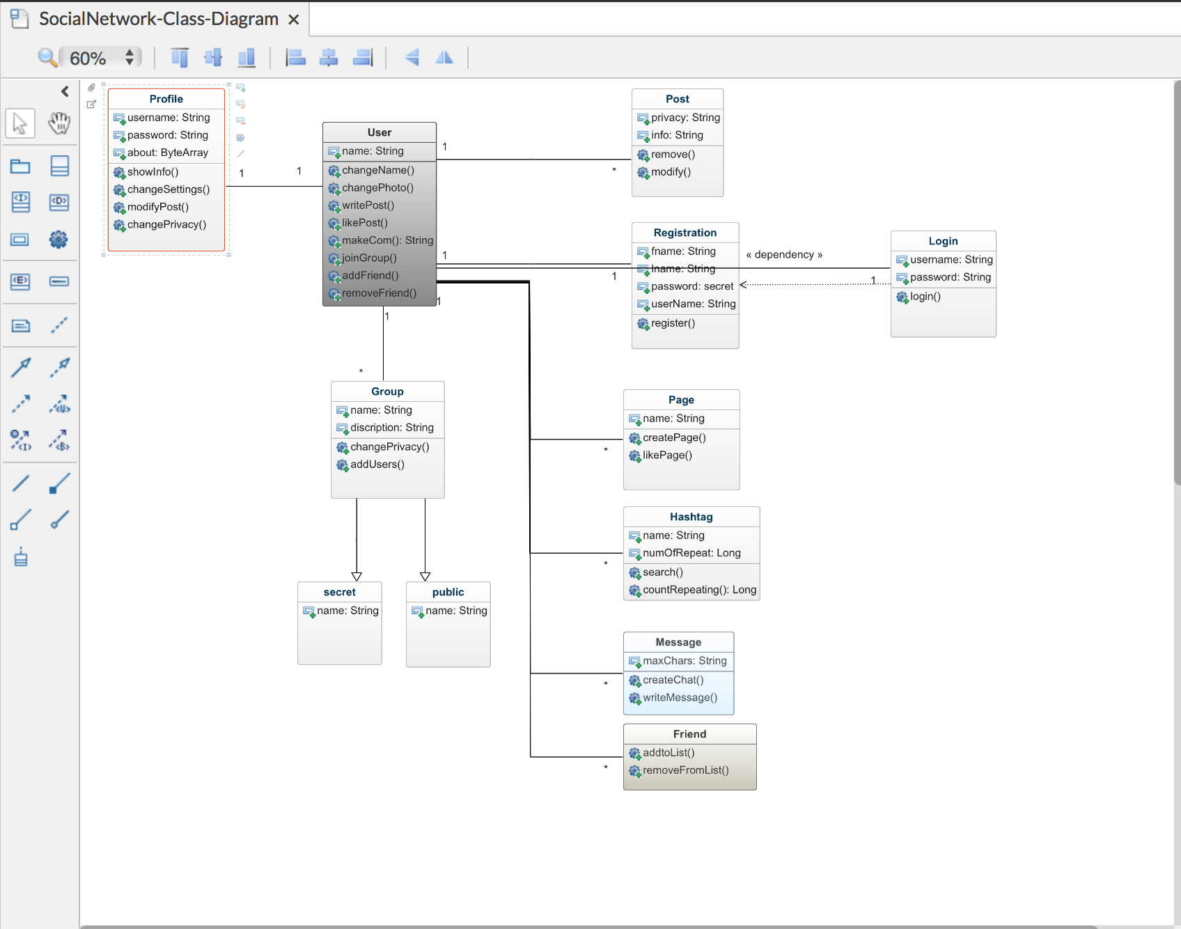

**Main page**

Including business description, and contact information

Map and Directions

Photo Gallery

Places to Go

With Reviews

Video Chat

Live post and Streaming

External Data used

<p><a href="https://www.getyourguide.com" target="_blank">Places to Go!!</a></p>

<p><a href="https://www.google.com/maps/@26.3361661,-98.1279967,15z" target="_blank">Directions</a></p>

<p><a href="https://weather.com" target="_blank">Weather</a></p>

<p><a href="skype:-skype-name-?chat" target="_blank">Start chat</a></p>

<img src="images/The Link.png" width="1100" height="400" alt="The Link">

Programming Language | C#.NET

The website is being wrote using Hypertext Markup Language (HTML) and cascading Style Sheets (CSS). HTML is the language in which most of the websites are writing. HTML is used to create pages and make them functional. The code used to make them visually appealing is known as CSS and we shall focus on this in a later tutorial. For now, we will focus on teaching you how to build rather than design. It has a couple of tags and attributes. They work together but performs different functions. This Tags are used to mark up the start of an HTML element. One classic example of Tag is: <h1>. This HTML was used in building blocks. Other Tags used were <img/> and <imput/>. The Tag such as Tags such as <**img** /> and <**input** /> directly introduce content into the page. Other tags such as <**p**> surround and provide information about document text and may include other tags as sub-elements. Browsers do not display the HTML tags, but use them to interpret the content of the page. HTML elements are the building blocks of HTML pages. With HTML constructs, images and other objects such as interactive forms may be embedded into the rendered page. HTML provides a means to create structured documents by denoting structural semantics for text such as headings, paragraphs, lists, links quotes and other items. HTML can embed programs written in a scripting language such as Java script, which affects the behavior and content of web pages. Inclusion of CSS defines the look and layout of content. The word wide web (W3C), maintainer of both the HTML and the CSS standards, has encouraged the use of CSS over explicit presentational HTML since 1997.

HTML was used to start my text editor and CSS was used to create the properties, declarations, selectors and the style rules.

Project Classes Code

**The Link social.html**

<!DOCTYPE html>

<html lang="en">

<head>

<title>The Link</title>

<!--

The Link social media main page

Filename: The Link.html

Author: Rolando Ortega

Date: 2/13/2019

-->

<meta charset="utf-8">

<meta name="viewport" content="width=device-width">

<script src="modernizr.custom.62074.js"></script>

<link href="https://fonts.googleapis.com/css?family=Bitter" rel="stylesheet"type='text/css'>

<link href="style.css" rel="stylesheet" type="text/css" />

<link rel="shortcut icon" href="images/favicon.ico">

<link rel="apple-touch-icon" href="images/apple-touch-icon.png">

<link rel="icon" sizes="192*192" href="images/android.png">

</head>

<body>

<div class="container">

<p class="skipnavigation"><a href="#contentstart">Skip navigation</a></p>

<p> Let's get connected </p>

<header>

</nav>

<article>

<p id="contentstart">

<div>

<h2></h2>

<p class="accent">A Place to meet <span class="accent">&amp; look for friends and places</p>

</div>

<h1>The Link</h1>

<form>

<p>Log In</a></p>

</div>

<div id="container">

<label for="username">Username:</label>

<input type="text" id="username" name="username">

<label for="password">Password:</label>

<input type="password" id="password" name="password">

<div id="lower">

<input type="checkbox"><label for="checkbox">Keep me logged in</label>

<input type="submit" value="Login">

</div><!--/ lower-->

</form>

<nav class="sitenavigation">

<p><a href="Home.html" target="_blank">Home</a></p>

<p><a href="Photos.html"target="_blank">Photo Gallery</a></p>

<p><a href="Live Post and Streaming.html"target="_blank">Live Post and Streaming</a></p>

<p><a href="https://www.getyourguide.com" target="_blank">Places to Go!!</a></p>

<p><a href="https://www.google.com/maps/@26.3361661,-98.1279967,15z" target="_blank">Directions</a></p>

<p><a href="https://weather.com" target="_blank">Weather</a></p>

<p><a href="skype:-skype-name-?chat" target="_blank">Start chat</a></p>

<img src="images/The Link.png" width="1100" height="400" alt="The Link">

</header>

</div>

<footer>

<p id="contact"><span class="accent">Rolando</span> &#8226; Ortega (956)800-8917</p>

</footer>

</html>

**Style.css**

/* body*/

body {

max-width: 1200px;

margin: 0 auto;

border-left: 3px solid black;

border-right: 3px solid black;

border-bottom: 3px solid black;

background-color: beige;

text-align: left;

font-family: Tahoma, Arial, Helvetica, sans-serif;

box-shadow: 0 29px 6px -6px #777;

}

nav.sitenavigation p

{

display: inline-block;

margin: 0.5em;

float: center;

}

nav.sistenavigation {

/* width: 19%; */

/* padding: 3%; */

/* float: left; */

color: #3418f;

text-align: center;

float: center;

}

nav.sitenavigation p {

display: inline-block;

margin: 0.10em;

float: center;

}

nav.sitenavigation a: link{

text-decoration: none;

color: #34180f;

}

nav.sitenavigation a: visited {

color: #744f42;

}

nav.sitenavigation a: hover, nav.sitenavigation a:focus {

color: ivory;

}

/* Basics */

p {

font-size: 1.4em;

line-height: 1.6em;

}

a: link {

color: black;

}

a: visited {

color: #888;

}

a: active {

position: relative;

top: 1px;

left: 1px;

}

}

#contact {

text-align:right;

}

.accent {

color: black;

}

h1, #contact {

background-color: wheat;

color:black;

position: right;

font-size: 2em;

}

/* reset styles*/

html {

font-size: 15px;

}

a, article, body, div, footer, header, h1, h2, p {

p {

font-size: 1.2em;

line-height: 1.4em;

padding: 0;

margin: 0;

}

img {

max-width: 400%;

height: auto;

width: 100;

position: center;

margin: relative;

}

/* body and page container */

.container{

max-width: 800px;

margin: 0 auto;

background-color: blue;

position: relative;

top: 6.2em;

}

/*heading */

h1,h2 {

padding: 0.8em;

text-align: right;

font-family:Bitter, "Times New Roman", Times, serif;

}

header {

width: 100%;

max-width: 640px;

position: fixed;

background-color: darkgreen;

/*z-index: -1;*/

}

/* skip navigation Link*/

p.skipnavigation a {

position: absolute;

left: -10000px

}

p.skipnavigation a:focus{

color: #34180f;

background-color: ivory;

top: 0.2em

left 0.4em

z_index 2;

}

h1 {

color: ivory

background-color: rgb(184,148,77);

font-size: 2em

padding: 0.8em;

color: black;

text-align: center;

text-shadow: -10px -5px 6px rgb(52,24,15);

}

h2 {

font-size: 3em

padding: 0.4em 0.6em;

vertical-align: : -50px;

}

p.logo {

padding: 0.2em;

border: 2px solid beige;

color: black;

position: all;

top: 2em;

left: 2em;

}

/* main content */

article {

/* width: 69%; */

margin: 0 auto;

padding: 0 3% 1em;

background-color: #7eccec;

background: url("images/ocean.png");

/* float: right; */

}

article{

width: 70%;

float: right;

}

article p{

padding: 0 1em 1em;

}

article p.imagemap{

text-align: center;

}

article p.imagemap img{

border: 1px solid black;

max-width: none;

}

article p: first-line{

font-weight: bold;

}

article p: first-letter {

font-size: 3em;

float: left;

line-height: 0.9em;

}

.tittle{

font-style: italic;

}

/* sidebar */

aside {

width: 30%;

padding: 1em 0;

background-color: goldenrod;

}

aside p {

border-bottom: 1px solid black;

border-top: 1px solid black;

padding: 0.4em 0;

margin: 0 0.6em;

}

/*footer section*/

footer{

padding: 0.6em

color:white;

background-color: rgb(24,24,24);

text-align: center;

/* clear:both; */

}

footer p {

margin: 0.4em;

}

.accent{

font-weight: bold;

}

footer p.accent{

color: goldenrod;

}

**Live Post and Streamin.html**

<!DOCTYPE html>

<html lang="en">

<head>

<title>Live Post and Streaming</title>

<p> Let's get connected</p>

<p> Live Post and Streaming</p>

<nav class="pagenavigation">

<!--

The Link social media main page

Filename: The Link.html

Author: Rolando Ortega

Date: 2/13/2019

-->

<meta charset="utf-8">

<meta name="viewport" content="width=device-width">

<script src="modernizr.custom.62074.js"></script>

<link href="https://fonts.googleapis.com/css?family=Bitter" rel="stylesheet"type='text/css'>

<link href="style.css" rel="stylesheet" type="text/css" />

</head>

<body>

<div class="container">

<p class="skipnavigation"><a href="#contentstart">Skip navigation</a></p>

<div>

<header>

<h1>The Link</h1>

<img src="images/The Link.png" width="1200" height="400" alt="The Link">

</header>

<nav class="sitenavigation">

<p id="contentstart">

**Photos.html**

<!DOCTYPE html>

<html lang="en">

<head>

<title>Photo Gallery</title>

<p> Let's get connected</p>

<p> Photo Gallery</p>

<nav class="pagenavigation">

<!--

The Link social media main page

Filename: The Link.html

Author: Rolando Ortega

Date: 2/13/2019

-->

<meta charset="utf-8">

<meta name="viewport" content="width=device-width">

<script src="modernizr.custom.62074.js"></script>

<link href="https://fonts.googleapis.com/css?family=Bitter" rel="stylesheet"type='text/css'>

<link href="style.css" rel="stylesheet" type="text/css" />

</head>

<body>

<div class="container">

<p class="skipnavigation"><a href="#contentstart">Skip navigation</a></p>

<div>

<header>

<h1>The Link</h1>

<img src="images/The Link.png" width="1200" height="400" alt="The Link">

</header>

<nav class="sitenavigation">

<p id="contentstart">

**Home.html**

<!DOCTYPE html>

<html lang="en">

<head>

<title>Home</title>

<p> Let's get connected</p>

<p> Home</p>

<nav class="pagenavigation">

<!--

The Link social media main page

Filename: The Link.html

Author: Rolando Ortega

Date: 2/13/2019

-->

<meta charset="utf-8">

<meta name="viewport" content="width=device-width">

<script src="modernizr.custom.62074.js"></script>

<link href="https://fonts.googleapis.com/css?family=Bitter" rel="stylesheet"type='text/css'>

<link href="style.css" rel="stylesheet" type="text/css" />

</head>

<body>

<div class="container">

<p class="skipnavigation"><a href="#contentstart">Skip navigation</a></p>

<div>

<header>

<h1>The Link</h1>

<meta charset ="utf-8" name="viewport" content="width=device-width, initial-scale=1">

<title>About me</title>

<link rel="stylesheet" href="https://cdnjs.cloudflare.com/ajax/libs/font-awesome/4.7.0/css/font-awesome.min.css">

</head>

<body>

<header>

<div class="name ">

Rolando

</div>

<div class="ava">

<img src="images/moto.jpg" width="200" height="200" alt="avatar" />

</div>

</header>

<div class="content">

<aside class="info ">

<div class="box">

<p class="title">

<i class="fa fa-info-circle"></i>Contact

</p>

<p class="padd-top">

<i class="fa fa-birthday-cake"></i>

08/08/1983

</p>

<p>

<i class="fa fa-phone"></i>

(956)800-8917

</p>

<p>

<i class="fa fa-envelope"></i>

ortega.rony0183@gmail.com

</p>

<p>

<i class="fa fa-home"></i>

Texas, US,

</p>

</div>

<div class="box">

<p class="title" >

<i class="fa fa-asterisk"></i>

Activity

</p>

<p class="padd-top">friend request</p><button onclick="myFunction()">Click </button>

<div class="skill">

<div class="skill-right r1"></div>

</div>

<p>About</p>

<div class="skill">

<div class="skill-right r2"></div>

</div>

<p>Champlain College</p>

<div class="skill">

<div class="skill-right r3"></div>

</div>

</div>

</aside>

<section class="main">

<div class="box">

<p class="title">

<i class="fa fa-graduation-cap"></i>

</p>

</div>

</div>

</section>

</div>

<footer> </footer>

</body>

</html>

<p>Click the button to get your coordinates.</p>

<button onclick="getLocation()">Try It</button>

<p><strong>Note:</strong> The geolocation property is not supported in IE8 and earlier versions.</p>

<p id="demo"></p>

<script>

var x = document.getElementById("demo");

function getLocation() {

if (navigator.geolocation) {

navigator.geolocation.getCurrentPosition(showPosition);

} else {

x.innerHTML = "Geolocation is not supported by this browser.";

}

}

function showPosition(position) {

x.innerHTML = "Latitude: " + position.coords.latitude +

"<br>Longitude: " + position.coords.longitude;

}

</script>

</body>

</html>

Program Start and End Flow

Start with a proposal, implementation of the design if the design was not approved redesign again and implemented a new design. If the design was approved information architecture is obtained. We design the web social media under the name the Link. First main page will show all the functionalities (Home, places to go, weather, video chat trough skype). User enter with a password and user name. User navigate through the different links under the main page. He finishing logging out.

**START**

**Proposal**

**Approved**

**Design Templates**

**Yes**

**No**

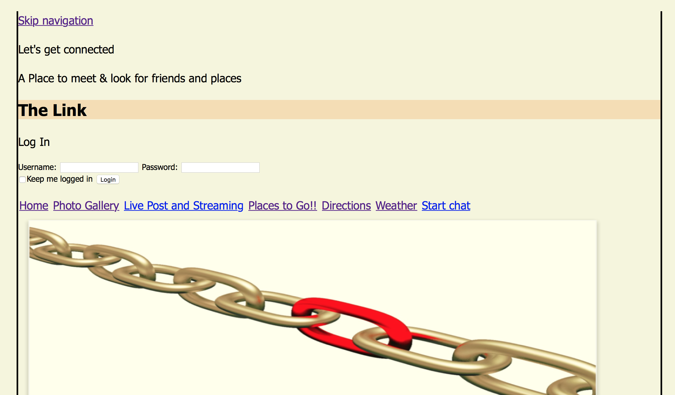

**END**

Redesign and start again

**Design**

**Program control is passed back to the application.**

**User can enter and Exit the Program using logging account**

|  |  |
| --- | --- |
| **215 UserInformation** | 1. Enter (password and user name) 2. Exit Log Off |

**Information Architecture**

Summary

I redesign the project in a way to obtain the best user experience and easy to follow. The addition of multiple pages following the rules of wire framing will be included. I include one page for user action and its results in another page. The colors and graphics were eliminated, because the color distracts from the information architecture, interaction design, and content. This will be done later on to improve the design. The addition of header, footer, navigation, content area all organized in a way that makes it usable were done. This is important to have for a better and easy structure to follow. This has or will been included it for each page so it doesn't interfere with the layout and then use an arrow to point from the annotation to where the key action is. The implementation of real text in text-based content was done. Example: in frequently questions and contact I added contact real information like address, phones and questions about my web story board. The header was implemented at the top of each page showing in what page you are. Navigation with multiples boxes to select has been done. One example under the Link main page we can observed in Live Post streaming a couple box to select like: Comment, Share Post and Share Video. The person in my story board has selected share a post, and open another window with the action of see and share the grand opening of the Food Park with all the attractions of this park. When you click under weather there is a new navigation tab that it will take you to the local weather forecast. The local weather forecast is a new window with the actual temperature, humidity and precipitation information. I also implemented under a logging page a new tab task called created an account, were the person it will be able to create a new account in order to log in to the Link page. This will open a page asking you for an email, username and password. Under suggested places I implement a list of places to go, each place its show by category.

Time frame will be take in consideration the addition of time will be implemented due to uncontrollable situations. The Mockup report will show the total time of work for the design, search and programing for each day of the week been on Wednesday the most time used for this task due to availability.

# APPENDIX B (BUILD AND RELEASE PROCESS)

To come to fruition, software projects take investment, support, nurturing and a lot of hard work and dedication. Good release management practices ensure that when your software is built, it will be successfully deployed to the people who want to use it.  First the user has to Understand the current state of release management. Our first step in improving our client's release management system was to form a detailed picture of the current release process. We began with a number of walk-through sessions with key individuals involved in the software process. Under this step the user can use test environments. Second, establish a regular release cycle. Once we got a picture of the current state of the process, we set about establishing a regular release cycle. Third trough the Lightweight process. This can be done doing a walk through another dry run, using only our documentation. Number fourth will consist of Establish a release infrastructure early. The release infrastructure covers the hardware, storage, network connections, bandwidth, software licenses, user profiles and access permissions. Human services and skills are part of the release infrastructure, too. For example, if you require specialist software installed and configured, it's not smart to exclude the availability or cost of getting such skills into your infrastructure plan. Fifth and last the Automatization and standardization Automation enables you to do repetitive tasks without tying up valuable human resources. Standardizing ensures that your automation's inputs and outputs are consistent every time. First, we initiated a prioritization exercise. The customer identified the highest-priority regression tests: the minimum they would accept as proof that the old functionality still worked. Then we set about automating this set. Subsequent acceptance tests also became automated, ensuring that we could regression test every release in hours rather than days.

# 

# APPENDIX C (CLIENT INSTALLATION INSTRUCTIONS)

1. Proper position of the files into a same directory (since is not in the net yet).
2. Double click on file showing The Link social.html it will pop the main page.
3. From there it will give you the option to logging using a password and username.
4. Once the user Log in, can navigate different options such weather, home page, where to go etc.
5. Double click under where to go tab it will redirect you to an external web called get your guide.
6. Subject can search places and events under this page.
7. Please also double click on weather tab for information of the weather on that particular are.
8. This was possible using external link from weather channel.
9. Under Home page user can chat trough Skype.
10. The design for this is only for chat, no phone calls.
11. Also under Home page, I implemented a current GPS locator.
12. The GPS locator is positioned under the page.

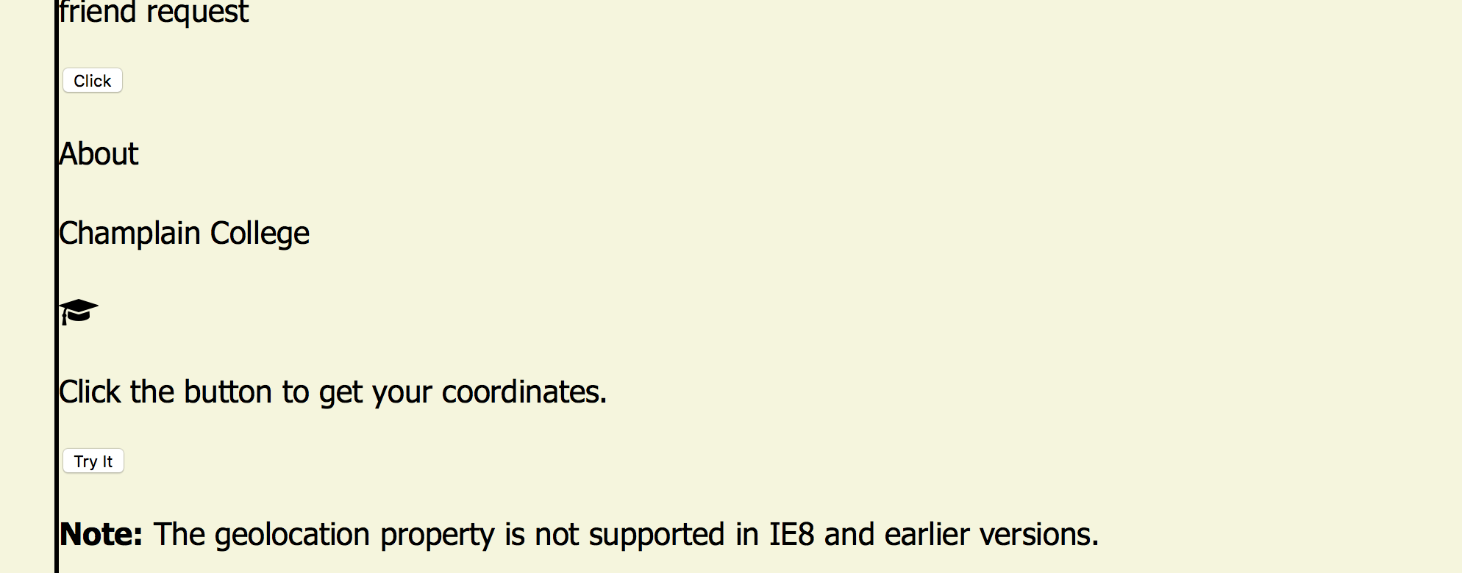

**Note:** The geolocation property is not supported in IE8 and earlier versions.

1. If the user design to finish his/her section please log out for security.

******Note please make sure all the files are located in the same directory ******

# APPENDIX D (DEVELOPER SETUP INSTRUCTIONS)

1. You can do it setting your computer with Sublime txt or any other text editor.
2. Other options if you have a PC and use Windows, you can use Notepad, the most basic text editor on your computer. If you have a Mac with OS X, you can use TextEdit.
3. On a PC, open Start > Programs > Accessories > NotePad On a Mac, open Finder > Applications > TextEdit
4. When I’m using Windows, I use these programs:

[Notepad++](http://notepad-plus.sourceforge.net/uk/site.htm): a powerful text editor for the PC. Free and open source.

[PaintShop Pro](http://www.corel.com/): a really excellent image editor. It’s shareware, so you’ll need to pay for it after a while. You also get Animation Shop, to make GIF animations.

[FileZilla](http://filezilla.sourceforge.net/): once your site is built, you need to [FTP it onto the Internet](https://www.yourhtmlsource.com/myfirstsite/uploading.html). FileZilla is a free piece of software for this.

1. When I’m using my Mac, I use:

[TextMate](http://macromates.com/) is a terrific text editor which can do syntax highlighting for dozens of common markup and programming languages.

[Transmit](http://www.panic.com/transmit/) is my favorite FTP program on the Mac.

**Other option:**

## **1. Select an Element**

In your portfolio, you see the webpage with a header bar at the top that contains the title The Link with an image. But when you scroll down the page, the header bar disappears, and the footer bar is not visible until you scroll to the bottom. Because this is a portfolio, you’ll want to make the header with the name and the footer with the photo count persistent when scrolling, especially on mobile devices.

To do this, you select an element and change its CSS properties. In this case, you will select the header element, by doing either of the following:

* Right click the element (in this case, the header The Link), and select Inspect Element from the menu.
* In Web Inspector, click the Element Selection button (see the figure below). Then move the pointer to the header and click it when it becomes highlighted.

After you select an element, Web Inspector automatically takes you to the element in the Elements tab. This tab displays a hierarchical structure of your HTML file with all the Document Object Model (DOM) elements. The path of DOM elements nested around the selected element is visible in the jump bar at the top of the Elements Tab (see the figure below). The DOM is partially unfolded, and the header markup identified by the tag <header> is highlighted.

## **2. Modify and Save CSS Properties in the Elements Tab**

At the right side of the Elements tab is a sidebar divided into three sections. The default section in focus when you select an element is the Styles sidebar. It shows all of the CSS styles that pertain to the selected element.

The Styles sidebar is open from when you selected the header element. You need to change the property for the header’s position.

1. In the Styles sidebar, click inside the CSS section for the header.
2. Add the position property by entering position: fixed;
3. Press Command-S to save the file with the new position property.

You can save any CSS changes made in the Elements tab to the original file. A popup window appears, asking you for the name of the file. Because the file already exists in your directory, you may also be asked to replace the original file with the new, changed file.

## **3. Open the CSS file with Quick Open**

Next you need to add a property so a photo zooms in when you hover over it. This hover property will give a better indication of the photo being selected. To do this, you go into the index.min.css file using Quick Open (see the figure below), a feature that allows you to quickly search for a file in Web Inspector.

1. Press Command-Shift-O, and start typing index.min.css until the file name autocompletes.
2. Press Enter.

Web Inspector takes you to the correct file and opens the Resources tab.

**Note:** Theindex.min.css file is minified. Web Inspector’s environment automatically displays minified files in a readable format.

## **4. Search Within a File**

Now you need to find the .photo-wrapper img property, so you can add the hover property immediately after it in the CSS file.

1. Press Command-F to make the Search bar appear at the top of the Resources tab.
2. Start typing .photo-wrapper img.

## **5. Modify the CSS Properties in the Resources Tab**

After you find the CSS block in the file, you need to add another property and create a new hover block.

## **6. Test Your Page in Responsive Design Mode**

Now that you have fixed these properties, check your page to see how it looks on different devices. A webpage that looks good on many devices is called responsive because it visually adapts to the device on which it is displayed. Responsive design ensures that your content automatically fits any screen size. To test your webpage’s responsiveness, you first need to enter Responsive Design Mode.

The elements on your webpage are resized to fit the device you selected. Multiple clicks on the same icon can change the orientation of the device. In the case of the iPad devices, multiple clicks can enable split screen views of your webpage. In the mobile device views, you can see that the images resize to fit the screen and that the header and footer stay fixed.

# Credits & References

Demystifying the 5 Phases of Project Management. (2019, January 16). Retrieved from <https://www.smartsheet.com/blog/demystifying-5-phases-project-management>

“Facebook's Top 14 Usability Mistakes and How to Fix Them.” IJoomla Blog Facebooks Top 14 Usability Mistakes and How to Fix Them Comments

HTML5 and CSS3 Illustrated: Introduction 2nd ed., Sasha Vodnik, Cengage / 2016, 9781305394056

Inline Styles in HTML. (n.d.). Retrieved from <https://www.codecademy.com/articles/html-inline-styles>

Interaction Design: Beyond Human-Computer Interaction Jenny Preece, University of Maryland

Helen Sharp, The Open UniversityYvonne Rogers, Sussex University

(n.d.). Retrieved from <http://users.ece.utexas.edu/~valvano/Volume1/E-Book/C7_DesignDevelopment.htm>

Web Inspector Tutorial. (2016, December 12). Retrieved from https://developer.apple.com/library/archive/documentation/NetworkingInternetWeb/Conceptual/Web_Inspector_Tutorial/EditingCode/EditingCode.html